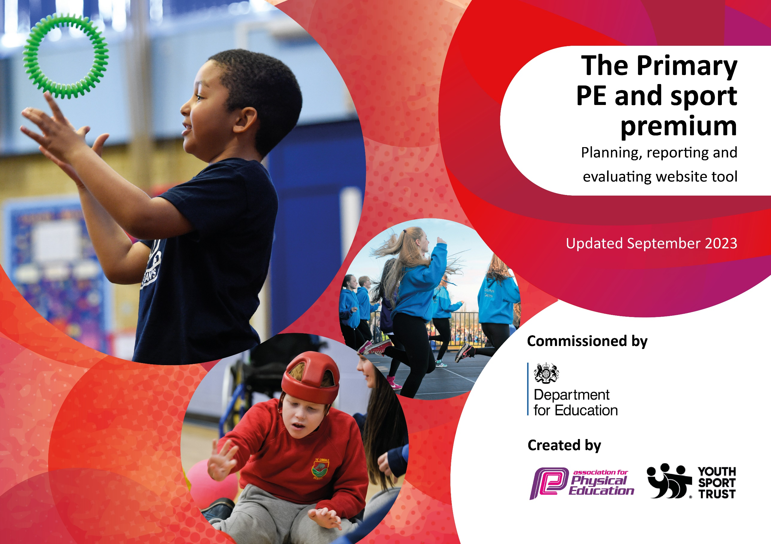

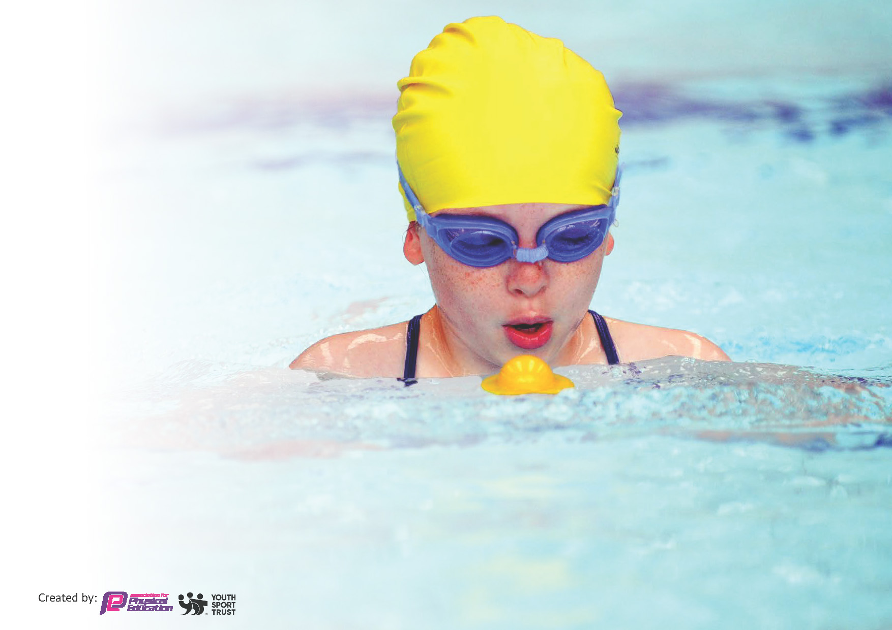
This template can be used for multiple purposes:
by:
- It enables schools to effectively plan their use of the Primary PE and sport premium
- It helps schools to meet the requirements (as set out in guidance) to publish information on their Primary PE and sport premium
- It will be an effective document to support Ofsted inspections enabling schools to evidence progress in Physical Education (PE) and evidence swimming attainment, which forms part of the PE National Curriculum. We would recommend schools consider
the Intent, Implementation and Impact of any spend, as examined within the Education Inspection Framework.

It is important that your grant is used effectively and based on school need.

Schools must use the funding to make additional and sustainable
improvements to the quality of the PE, School Sport and Physical Activity (PESSPA)
they offer. This means that you should use the Primary PE and sport premium to:

- Build capacity and capability within the school to ensure that improvements made now will benefit pupils joining the school in future years
- Develop or add to the PESSPA activities that your school already offers.

The Primary PE and sport premium should not be used to fund capital spend projects; the school’s core budget should fund these. Further detail on capital expenditure can be found in the updated Primary PE and sport premium guidance.

The Primary PE and sport premium guidance, outlines 5 key priorities that funding should be used towards. It is not

necessary that spending has to meet all the key priorities, you should select the priorities that you aim to use any funding towards.

Although completing this template is not a requirement for schools, schools are required to publish details of how they spend this funding. Schools must also outline what the impact this funding has had on pupils’ PE and sport participation and attainment and how any spending will be sustainable in the future. All funding must be spent by 31st July 2024.

The Department for Education has worked closely with the Association for Physical Education (afPE) and the Youth Sport Trust (YST) to develop this template and encourages schools to use it. This template is an effective way of meeting the reporting requirements of the Primary PE and sport premium.
Review of last year’s spend and key achievements (2023/2024)

We recommend you start by reflecting on the impact of current provision and reviewing your previous spend.

Activity/Action | Impact
PE curriculum development through the use of PEplanning.org to supplement and provide a structure for mixed age lesson. All children participated in 2 PE lessons per week for 2 hours. Sports Coach employed from January 2024.  Extra-curricular sports clubs have run in a variety of sports. Broadened lunch and break time resources.  Subsidised swimming lessons for Years 3 – 6 (12 week programme)  Development of our Football team and weekly training sessions developing competitive team work and sense of pride to be representing our school at matches with local schools.  Olympian visit  Subsidisation of activities and trips for disadvantaged pupils. to ensure that all pupils have the opportunity to access sporting activities/ events.  Development of EYFS garden to provide high quality environment for outdoor learning. | Progression of PE skills across year groups is planned effectively and staff are aware of what they should be teaching when. CPD also being accessed by staff to upskill in areas of weakness. High quality PE lessons consistently across all year groups. Increased staff confidence and knowledge. More pupils meeting their daily physical activity goal, more pupils encouraged to take part in PE and sport activities  Improvement in swimming attainment at the end of KS2. The majority of pupils have good water confidence and stroke technique by the end of KS2  Weekly training sessions for our team as well as inter school matches developed sense of pride and resilience. Team work, communication and respect instilled in the children to ensure that they are able to support, lead and negotiate within the team.  Aspiration to become involved in sport created. Children can talk about role models in sport and understand how they got to where they are today.  All pupils have had the opportunity to access a variety of outdoor adventure activities. No children missed out on any physical activities due to cost. Raised the profile of teamwork and physical activity in school.  Environment is an inviting learning space which houses new and improved resources to develop physical development – coordination, negotiate space, develop strength, balance and co ordination and be able to move freely. Children have a greater urge to be outdoors, in turn developing a love of being physically active.

Key priorities and Planning
This planning template will allow schools to accurately plan their spending.

Action – what are you planning to do | Who does this action impact? | Key indicator to meet | Impacts and how sustainability will be achieved? | Cost linked to the action
To broaden the range of extra-curricular sports and activities offered to pupils and to embed physical activity at break and lunchtimes.  To fund a specialist sports coach to deliver high quality PE lessons.  Hire swimming coaches to provide teaching in swimming lessons to enable swimming across the school.  Increased participation in competitive sports with other schools for all age groups.  Create a programme of cycling to encourage  safe participation in cycling as a physical activity and a  sustainable active way to travel. | All pupils  Sports Coach  Sports Coach  All children  All pupils in Years 3 – 6.  Teachers  All pupils  Year 5 and 6 to access cycling proficiency training both in  school and on the roads.  Years R and 1 to have specialist balance bike training. | Key indicator 3: The profile of PESSPA being raised across the school as a tool for whole school improvement  Key indicator 4: Broader experience of a range of sports and activities offered to all pupils.  Key indicator 2 -The engagement of all pupils in regular physical activity  Key Indicator 1: Increased confidence, knowledge, and skills of all staff in teaching PE and sport.  Key indicator 2 -The engagement of all pupils in regular physical activity  Key Indicator 1: Increased confidence, knowledge, and skills of all staff in teaching PE and sport.  Key indicator 5: Increased participation in competitive sport.  Key indicator 2 -The engagement of all pupils in regular physical activity  Key Indicator 1: Increased confidence, knowledge, and skills of all staff in teaching PE and sport.  Key indicator 4: Broader experience of a range of sports and activities offered to all pupils. | We will continue to provide a range of afterschool clubs from Autumn 2024 onwards. After school clubs will include a variety of activities including Multisport, Football, Gymnastics, Forest Schools. Children will be encouraged to be active during lunchtimes through taking on the role of ‘Play Leaders’. Their role will be taking ownership and responsibility for motivating and inspiring others to be active.  To provide high quality sports coaching which will enable children to develop key skills and support teachers in delivering planned lessons and assessment of pupils. Teachers are becoming increasingly confident with the practical elements of delivering activities/sports.  Provide high quality swimming coaching for children in Years 3 - 6 to ensure that at least 85% of children are able to swim  at least 25m and High Achievers develop Life Saving Skills. The target is that 100% of Year 6 children can meet the national curriculum swimming standards. The majority of funding for this will be met by parents and the core budget with  some sport premium funding being used to train staff and  provide top up swimming lessons where needed.  Coordinate competitions and enable Hemington pupils to participate. This will include girls and boys football competitions and the  inter school sports competitions within the Charnwood College schools partnership. Sports coach and teachers will supervise children at the events and prepare them for the competitions. Children to wear our kit to represent the school.  To encourage and develop safe cycling skills, firstly in a controlled off-road setting, developing positive attitudes towards road use, increase knowledge and understanding of the road and traffic environment and gain confidence to use their bikes on the road. | £1300  £11 100  £1702  £500  £2000

Key achievements 2024-2025
This template will be completed at the end of the academic year and will showcase the key achievements schools have made with their Primary PE and sport premium spending.

Activity/Action | Impact | Comments

Swimming Data
Meeting National Curriculum requirements for swimming and water safety.
Priority should always be given to ensuring that pupils can perform safe self-rescue even if they do not fully meet the first two requirements of the National Curriculum programme of study

Question | Stats: | Further context  Relative to local challenges
What percentage of your current Year 6 cohort can swim competently, confidently and proficiently over a distance of at least 25 metres? | 100% | 10/10 children.
What percentage of your current Year 6 cohort can use a range of strokes effectively [for example, front crawl, backstroke, and breaststroke]? | 90% | 9/10 children

What percentage of your current Year 6 cohort are able to perform safe self-rescue in different water-based situations? | 90% | 9/10 children
If your schools swimming data is below national expectation, you can choose to use the Primary PE and sport premium to provide additional top-up sessions for those pupils that did not meet National Curriculum  requirements after the completion of core lessons. Have you done this? | Yes/No
Have you provided CPD to improve the knowledge and confidence of staff to be able to teach swimming and water safety? | Yes/No

Signed off by:

Co - headteachers: | Andrea Reay & Lucy Timbrell
Subject Leader or the individual responsible for the Primary PE and sport premium: | Lucy Timbrell
Governor: | Liz Cordon & Craig Witton (Co – Chairs)
Date: | 19/07/2024

